Week 11 - Day 1 (Finishing streams & Carets)

Table of Contents

[CS 403 - 001 Spring 2016](/CS403-001/)

[About](/CS403-001/about/)

# Week 11 - Day 1 (Finishing streams & Carets)

Mar 31, 2016

Download Word (docx):

Download PDF:

## Navigate using audio

## Where we left off…

We were working on getting a stream of convergences to pi

(define (let s)  
 (define s0 (scar s))  
 (define s1 (scar (scdr s)))  
 (define s2 (scar (scdr (scdr s))))  
 (define denominator (+ s0 (* -2 s1) s2))  
 (scons  
 (- s2 (/ (^ (- s2 s1) 2) denominator ))  
 (et (scdr s))  
 )  
)  
  
;@ Audio 0:03:14  
(define (tableau xform s) (scons s (tableau (xform s))))

Audio 0:04:00

The state of the world is not being saved…

Audio 0:05:12

The tableau applies the stream an extra time after each transform

(print "2 xform: ")  
(sdisplay (sscale (et (et (psum pi-stream))) 4) 10)  
;@ Audio 0:06:54

Audio 0:07:30 A map function for streams

(define (smap f s) (scons (f (scar s)) (smap f (scdr s))))

Audio 0:08:50

(sdisplay (sscale (smap scar (tableau et (psum pi-stream))) 4) 10)

Audio 0:16:00

for (i = 0; i < infinity; i++) {  
 for (j = 0; j <= i; j++) {  
 print("(%d,%d)",j,i)  
 }  
}

Creates the stream of pairs: (0,0),(0,1)(1,1)(0,2)(1,2)(2,2)

Which are pairs s.t. i <= j

Audio 0:19:43

(define (pairs s t)

Breaking it up into:

(0,0) (0,1) (0,2) (0,3) (0,4)

(1,1) (1,2) (1,3) (1,4)

(2,2) (2,3) (2,4)

Audio 0:22:00

(pairs (0 1 2 ...) (0 1 2 ...)....

(define (pairs s t)  
 (scons  
 ;@ This only takes care of the (0,0)  
 (list (scar s) (scar t))  
 (smap (lambda (x) (list (scar s) x))  
 (scdr t))  
 ;@ Audio 0:27:00  
 (pairs (scdr s) (scdr t))

Do the Lusth Shuffle

Audio 0:31:10

;@ You have   
;@ a b c d e ... and  
;@ A B C D E  
;@ v  
;@ v  
;@ a A b B c C d D e E ...  
(define (shuffle s t)  
 (scons   
 (scar s)  
 (shuffle t (scdr s))  
 )  
)

(define (pairs s t)  
 (scons  
 ;@ This only takes care of the (0,0)  
 (list (scar s) (scar t))  
 (shuffle  
 (smap (lambda (x) (list (scar s) x))  
 (scdr t))  
 ;@ Audio 0:27:00  
 (pairs (scdr s) (scdr t))  
 )

Audio 0:35:00 Caret dog ayyyy lmao

Caret dog world changes over time

Streams, on the other hand, look like they change, but they don’t

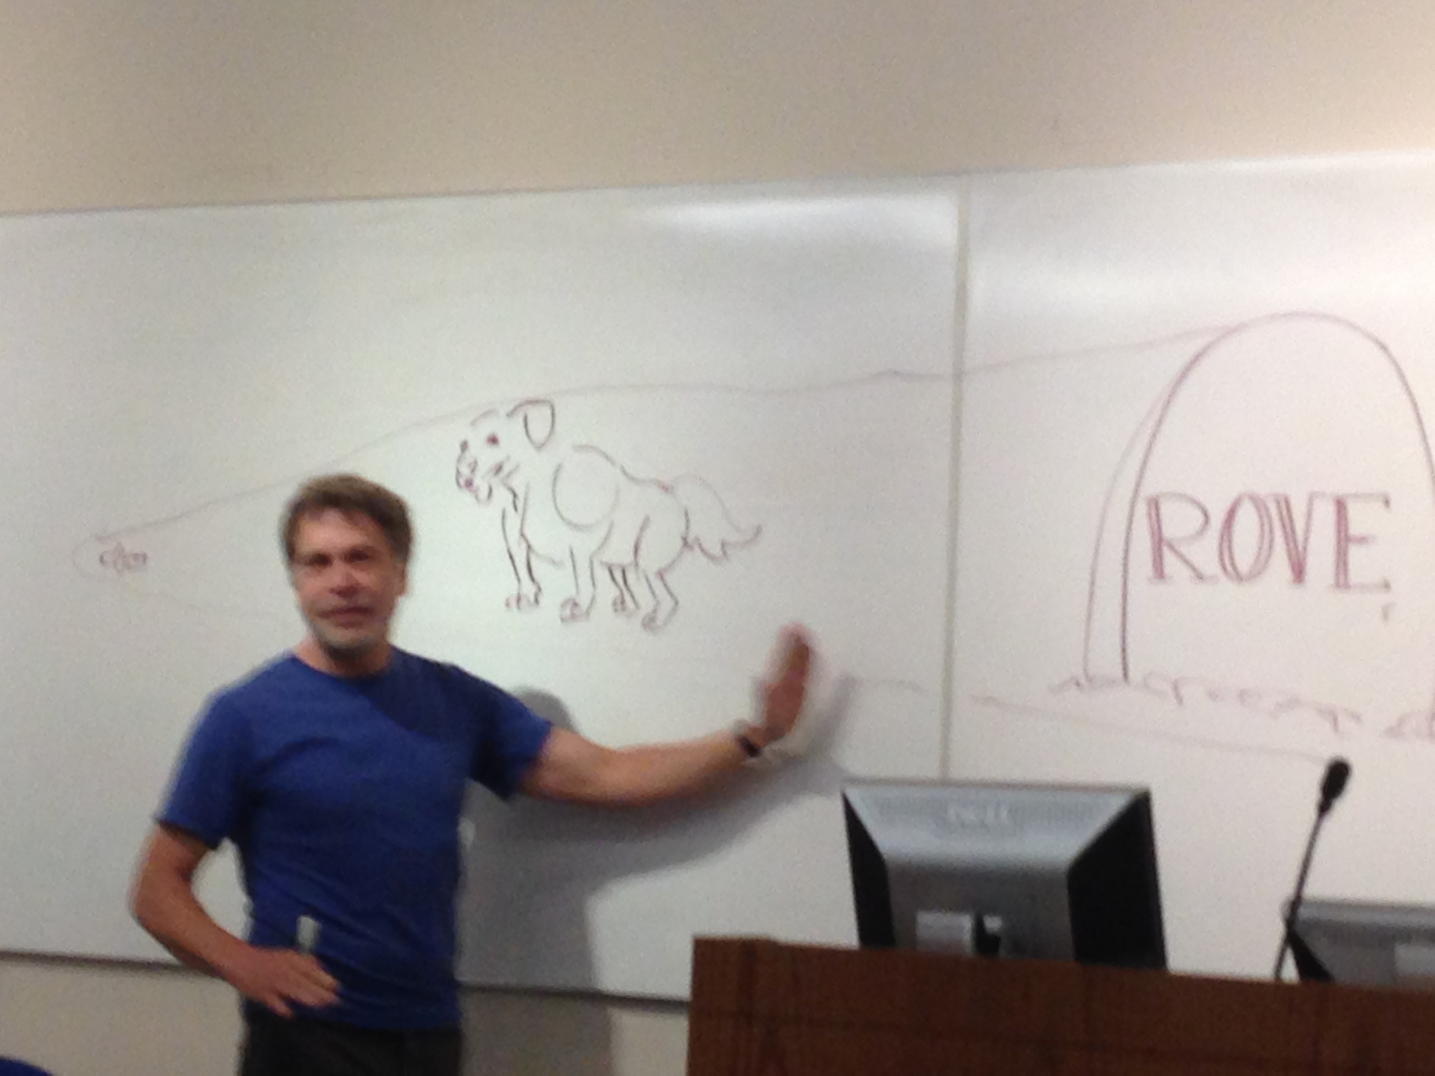

## CS 403 - 001 Spring 2016

* CS 403 - 001 Spring 2016
* [jmbeach1@crimson.ua.edu](mailto:jmbeach1@crimson.ua.edu)
* jmbeach

Website for notes and study material for CS 403 (Programming Languages) at The University of Alabama Spring 2016